**PYTHON INSTALLATION GUIDE & SETTING UP YOUR ENVIRONMENT!**

**INSTALLING PYTHON**

**Step 1**: Visit : <https://www.python.org/downloads/release/python-373/>

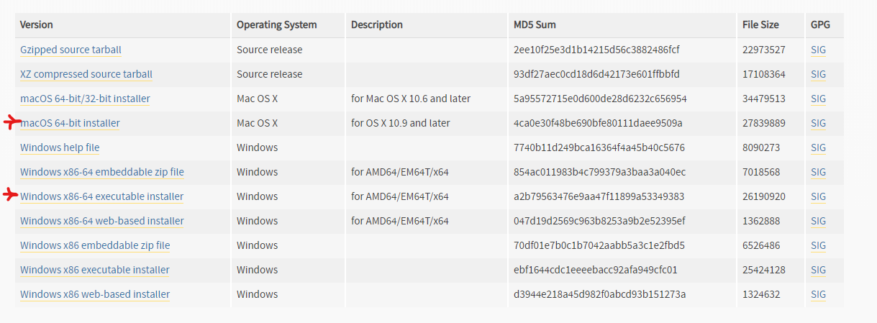  
**Step 2**: Downloading Installer:

For windows users: download the windows executable file

For mac OS users: download the macOS 64 bit installer

**Step 3**: Run the installation File

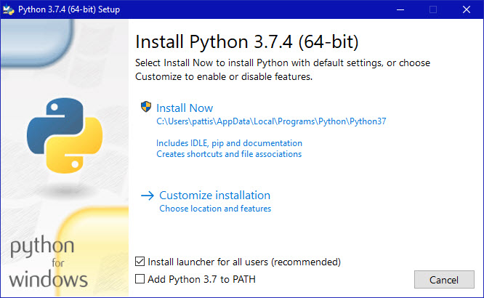

**Step 4**: Select the “ ADD PYTHON 3.7 to PATH OPTION”

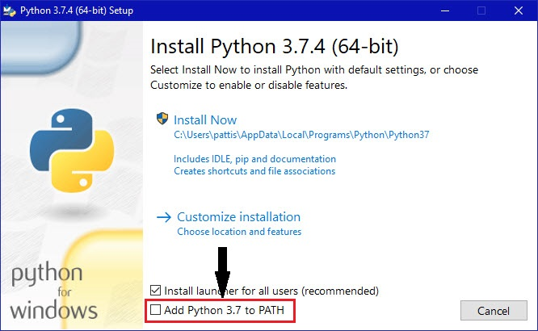

**Step 5**: Click on Install Now

**SETTING UP YOUR ENVIRONMENT!**

Once installation is complete,

**Step 1**: Click -> Win key + R

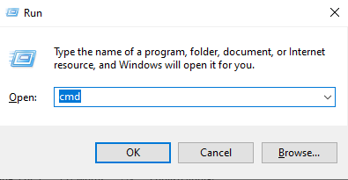**Step 2**: Type in “cmd” and hit Enter

{Optional step 3: to check if python has been installed properly: type python in cmd window and hit enter, if it works, then it’s properly installed otherwise you missed a step in last tutorial and need to reinstall it}

**Step 4**: type “ pip install virtual env ” and hit Enter



**Step 5**: type “ pip install jupyter ” and hit Enter



Step 6: type “ pip install --upgrade pip ” and hit enter

**GETTING STARTED WITH PYTHON!**

Step 1: Open command prompt (Win + R => Type “cmd” hit enter)

Step 2: Type “jupyter notebook” and hit Enter

Step 3: Once this page opens

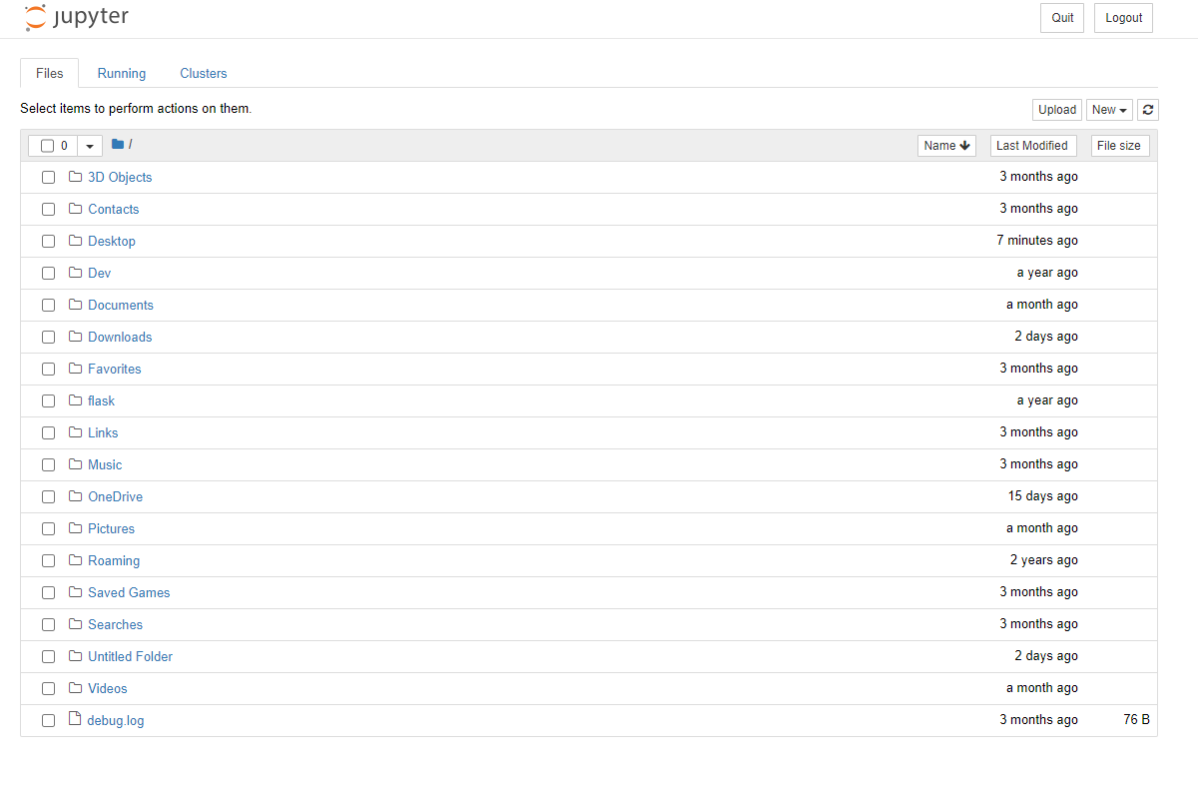

CLICK ON NEW AND CREATE A NEW FOLDER. (IT WILL BE BY DEFAULT NAMED THE UNTITLED FOLDER)

Step 4: Once the new folder shows up in your list, click on it and now you are good to go!

LET’S START THE JOURNEY OF LEARNING PYTHON & AI